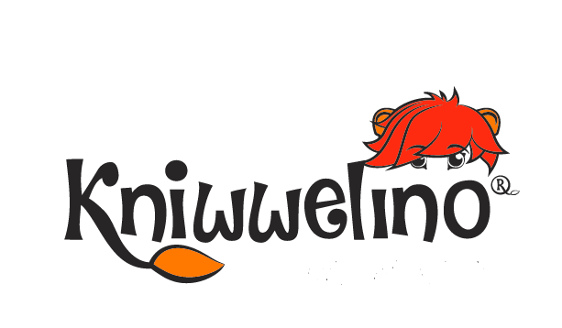


Think Spot Journal

Student’s Name:…………………………
Class:…………………



Introduction
- How did you feel about today's lesson?
- What were your favorite parts about the activities?
- Were you able to give algorithms to your classmate or were you able to follow your classmate’s algorithms to brush the teeth?
- Would it have been harder or easier if the algorithm had been only one step: "Brush the teeth"?
- What if you had not organized the steps in order: what would have happened?

___________________________________________________________________________________________________ ___________________________________________________________________________________________________________________________________________________________________________________________________________________________________________________________________________________________________________________________________________________________________________________________________________________________________________________________________________________________________________________________________________________________________________________________________________________________________________________________________________________________________________________________________________________________________________________________________________________________________________________________________________________________________________________________
__________________________________________________________________________________________________________________________________________________________________________________________________________________________________________________________________________________________________________________________________________________________________________________________________________________________________________________________________________________________________________________________________________________________________________________________________________________
__________________________________________________________________________________________________________________________________________________________________________________________________________________________________________________________________________________________________________________________________________________________________________________________________________________________________________________________________________________________________________________________________________________________________________________________________________________
_______________________________________________________________________________________________________________________________________________________________________________________________________________________________________________________________________________________________________________________________________________________________________________________________________________________________________________________________________________________________________________
___________________________________________________________________________________________________

Never say, “I can’t”

Always say, “I’ll try”

K001
What was today's lesson about? How did you feel about the lesson?

_______________________________________________________________________________________________________________________________________________________________________________________________________________________________________________________________________________________________________________________________________________________________________________________________________________________________________________________________________________________________________________
_______________________________________________________________________________________________________________________________________________________________________________________________________________________________________________________________________________________________________________________________________________________________________________________________________________________________________________________________________________________________________________
What is your idea about Kniwwelino?

__________________________________________________________________________________________________________________________________________________________________________________________________________________________________________________________________________________________________________________________________________________________________________________________________________________________________________________________________________________________________________________________________________________________________________________________________________________

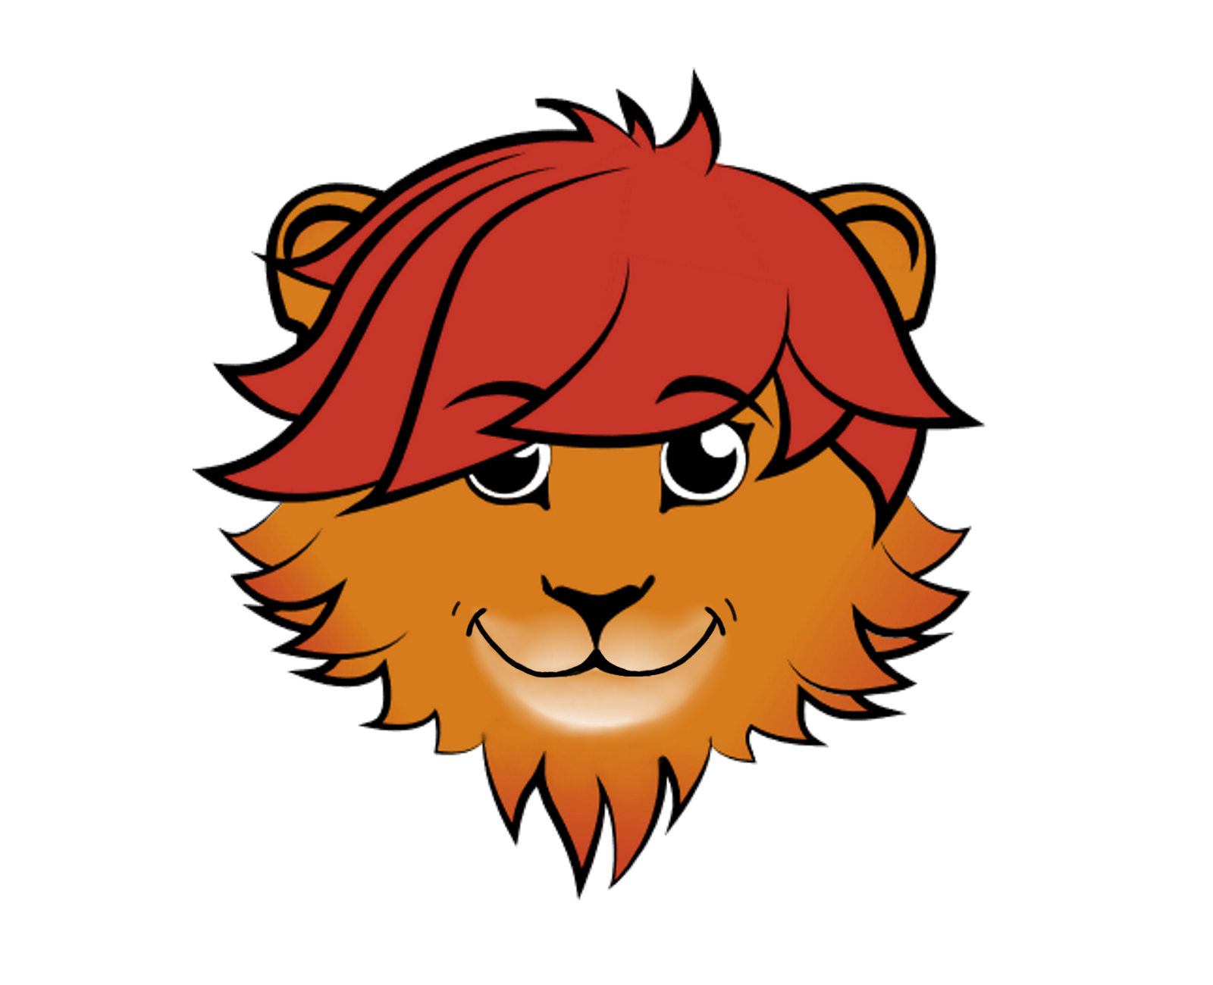

I can do it well
I didn’t get it at all
I did it but didn’t fully get it

I can distinguish the application of Buttons, RGB LED, and LED Matrix.

I can understand the use of Kniwwelino categories and blocks.

I can independently setup the online visual programming interface.

I can execute the program to tell Kniwwelino to display my name.

I can upload my program to my Kniwwelino.

Everything

You
Imagine

Do

You

It

Can

What was today's lesson about? How did you feel about today's lesson?

K002&3
_____________________________________________________________________________________________________________________________________________________________________________________________________________________________________________________________________________________________________________________________________________________________________________________________________________________________________________________________________________________________________________________________________________________________________________________________________________________________________________________________________________________________________________________
Did you learn programming the LED well?

?

__________________________________________________________________________________________________________________________________________________________________________________________________________________________________________________________________________________________________________________________________________________________________________________________________________________________________________________________________________________________________________________________________________________________________________________________________________________
Can you explain the steps for alternating the LED colours?
Can you explain the steps for alternating the LED colours?

__________________________________________________________________________________________________________________________________________________________________________________________________________________________________________________________________________________________________________________________________________________________________________________________________________________________________________________________________________________________________________________________________________________________________________________________________________________
Do you have any ideas about the applications of the LED in everyday life?

_______________________________________________________________________________________________________________________________________________________________________________________________________________________________________________________________________________________________________________________________________________________________________________________________________________________________________________________________________________________________________________
___________________________________________________________________________________________________

YOU
ARE
AMAZING
___________________________________________________________________________________________________

K004
What was today's lesson about?

K004

- What was today's lesson about?
- How did you feel about today's lesson?
- Draw other images to make an animation. Can you explain the program that goes with these drawing?
- What would have happened if you had not set the time between each image?

___________________________________________________________________________________________________
___________________________________________________________________________________________________ ________________________________________________________________________________________________________________________________________________________________________________________________________________________________________________________________________________________________________________________________________________________________________________________________________________________________________________________________________________________________________________________________________________________________________________________________________________________________________________________________________________________________________________________________________________________________________________________________________________________
__________________________________________________________________________________________________________________________________________________________________________________________________________________________________________________________________________________________________________________________________________________________________________________________________________________________________________________________________________________________________________________________________________________________________________________________________________________
__________________________________________________________________________________________________________________________________________________________________________________________________________________________________________________________________________________________________________________________________________________________________________________________________________________________________________________________________________________________________________________________________________________________________________________________________________________
_______________________________________________________________________________________________________________________________________________________________________________________________________________________________________________________________________________________________________________________________________________________________________________________________________________________________________________________________________________________________________________
__________________________________________________________________________________________________

BELIEVE

YOU CAN
&
YOU WILL

K005
What was today's lesson about?

_____________________________________________________________________________________________________________________________________________________________________________________________________________________________________________________________________________________________________________________________________________________________________________________________________________________________________________________________________________________________________________________________________________________________________________________________________________________________________________________________________________________________________________________
How did you feel about today's lesson?
?

__________________________________________________________________________________________________________________________________________________________________________________________________________________________________________________________________________________________________________________________________________________________________________________________________________________________________________________________________________________________________________________________________________________________________________________________________________________
What things do you do during the day under certain conditions?

__________________________________________________________________________________________________________________________________________________________________________________________________________________________________________________________________________________________________________________________________________________________________________________________________________________________________________________________________________________________________________________________________________________________________________________________________________________
Can you explain the steps of the program that you executed today?

_______________________________________________________________________________________________________________________________________________________________________________________________________________________________________________________________________________________________________________________________________________________________________________________________________________________________________________________________________________________________________________
___________________________________________________________________________________________________

Positive
be
think
Positive

K006

- How did you feel sending messages to your friends with Kniwwelino?
- Did you understand the application of blocks of the Messages category well?
- Can you use the blocks well to send various types of messages to your friends?
- Describe the steps for sending a message to your friends with Kniwwelino.

___________________________________________________________________________________________________
___________________________________________________________________________________________________ ________________________________________________________________________________________________________________________________________________________________________________________________________________________________________________________________________________________________________________________________________________________________________________________________________________________________________________________________________________________________________________________________________________________________________________________________________________________________________________________________________________________________________________________________________________________________________________________________________________________
__________________________________________________________________________________________________________________________________________________________________________________________________________________________________________________________________________________________________________________________________________________________________________________________________________________________________________________________________________________________________________________________________________________________________________________________________________________
__________________________________________________________________________________________________________________________________________________________________________________________________________________________________________________________________________________________________________________________________________________________________________________________________________________________________________________________________________________________________________________________________________________________________________________________________________________
_______________________________________________________________________________________________________________________________________________________________________________________________________________________________________________________________________________________________________________________________________________________________________________________________________________________________________________________________________________________________________________
__________________________________________________________________________________________________

You’re BRAVER

than you believe

&

SMARTER

Than you think

K007

- What was today's lesson about?
- Did you understand well the steps of today’s lesson?
- Can you explain the relationship between variable and value?
- Imagine of a technology in which today’s lesson can be integrated. What is it and how can it be used in our daily lives?

___________________________________________________________________________________________________
___________________________________________________________________________________________________ ________________________________________________________________________________________________________________________________________________________________________________________________________________________________________________________________________________________________________________________________________________________________________________________________________________________________________________________________________________________________________________________________________________________________________________________________________________________________________________________________________________________________________________________________________________________________________________________________________________________
__________________________________________________________________________________________________________________________________________________________________________________________________________________________________________________________________________________________________________________________________________________________________________________________________________________________________________________________________________________________________________________________________________________________________________________________________________________
__________________________________________________________________________________________________________________________________________________________________________________________________________________________________________________________________________________________________________________________________________________________________________________________________________________________________________________________________________________________________________________________________________________________________________________________________________________
_______________________________________________________________________________________________________________________________________________________________________________________________________________________________________________________________________________________________________________________________________________________________________________________________________________________________________________________________________________________________________________
__________________________________________________________________________________________________

DREAM BIG

K008
How did you feel about today's lesson?

_____________________________________________________________________________________________________________________________________________________________________________________________________________________________________________________________________________________________________________________________________________________________________________________________________________________________________________________________________________________________________________________________________________________________________________________________________________________________________________________________________________________________________________________
Can you make an if then else statement? Test whether the condition is true or false.
?

__________________________________________________________________________________________________________________________________________________________________________________________________________________________________________________________________________________________________________________________________________________________________________________________________________________________________________________________________________________________________________________________________________________________________________________________________________________
Did you understand well what the nested if statement is? Can you make an example?

__________________________________________________________________________________________________________________________________________________________________________________________________________________________________________________________________________________________________________________________________________________________________________________________________________________________________________________________________________________________________________________________________________________________________________________________________________________
Can you explain the steps of the program that you executed today?

_______________________________________________________________________________________________________________________________________________________________________________________________________________________________________________________________________________________________________________________________________________________________________________________________________________________________________________________________________________________________________________
___________________________________________________________________________________________________

© Luxembourg Institute of Science and Technology, 2020
This document is licensed under a Creative Commons Attribution 4.0 International License. Kniwwelino and the Kniwwelino lion are registered trademarks of the Luxembourg Institute of Science and Technology.

